Complete all questions in 1 hour.
- Draw the logic diagram of the following gates using logsim and complete the
Truth tables.
- AND
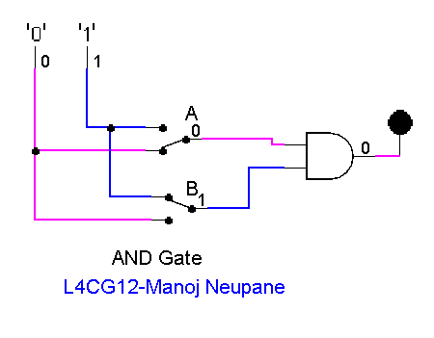

Truth Table of AND Gate
A | B | A.B
1 | 1 | 1
1 | 0 | 0
0 | 1 | 0
0 | 0 | 0

- NOR
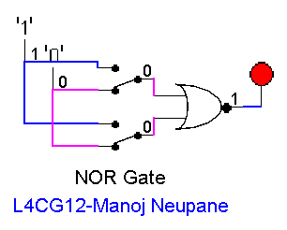

Truth Table of NOR Gate

A | B | (A+B)'
1 | 1 | 0
1 | 0 | 0
0 | 1 | 0
0 | 0 | 1

- OR
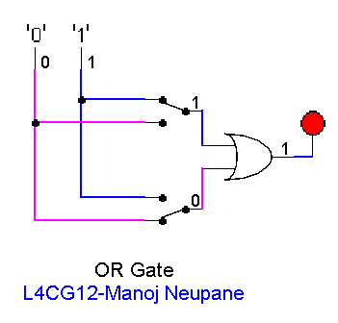

A | B | A+B
1 | 1 | 1
1 | 0 | 1
0 | 1 | 1
0 | 0 | 0

- NAND (using NOT and AND)

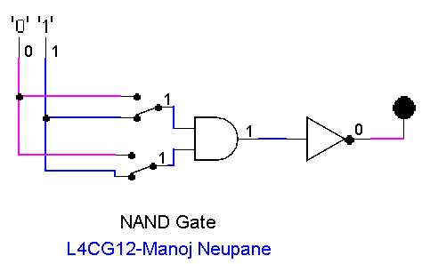

Truth table of NAND Gate

A | B | (A.B)'
1 | 1 | 0
1 | 0 | 1
0 | 1 | 1
0 | 0 | 1

- XOR using AOI
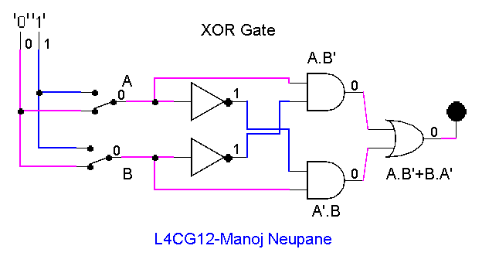

Truth Table of XOR (A.B’ + A’.B)
A | B | A.B' + A'.B
1 | 1 | 0
1 | 0 | 1
0 | 1 | 1
0 | 0 | 0

- Use LogSim to build the equivalent circuit for the following Boolean equations.
Prove that the expressions are equivalent by computing truth table.
$$!\left(A+B\right)=!A.!B$$
A | B | !(A+B) | !A . !B
0 | 0 | 1 | 1
0 | 1 | 0 | 0
1 | 0 | 0 | 0
1 | 1 | 0 | 0
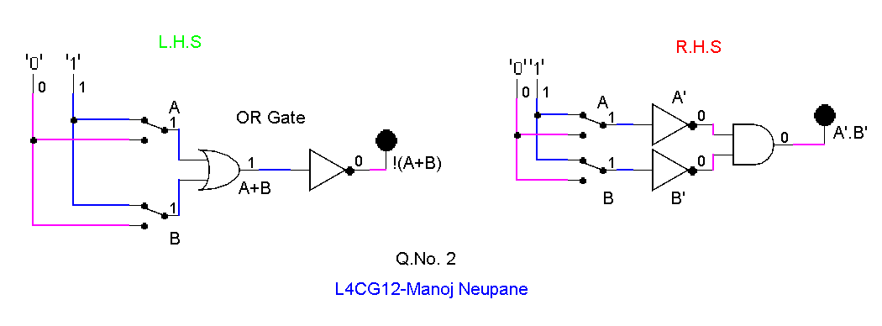

- Draw the following circuit of half adder using LogSim.

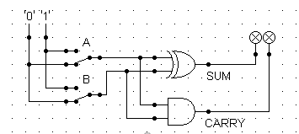

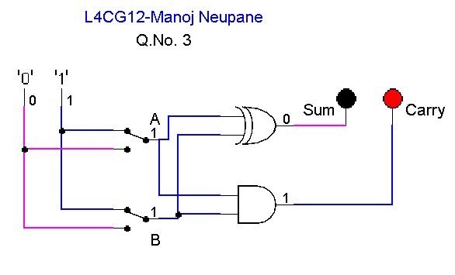

- Draw full adder using Logsim and construct truth table.

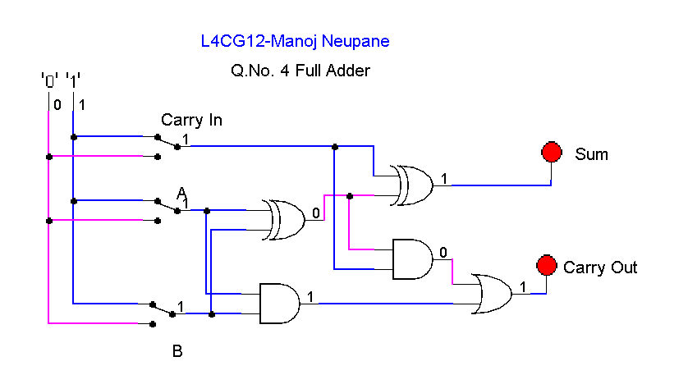

Full Adder Truth Table
A | B | C.in | Sum | C.out
1 | 1 | 1 | 1 | 1
1 | 1 | 0 | 0 | 1
1 | 0 | 1 | 0 | 1
1 | 0 | 0 | 1 | 0
0 | 1 | 1 | 0 | 1
0 | 1 | 0 | 1 | 0
0 | 0 | 1 | 1 | 0
0 | 0 | 0 | 0 | 0

- Draw the logic circuit for the following Boolean equations using logsim simulator.
  - AB+C
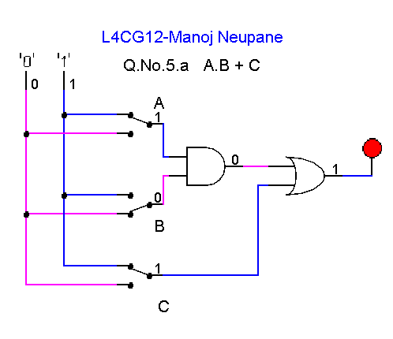

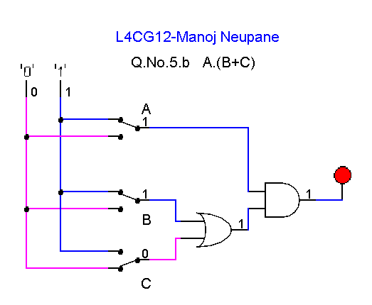
  - A(B+C)

  - X’Y’Z’
